Flavio Ranatunga

20908391

User guide

FINAL ASSESSMENT

DATABASE SYSTEMS – ISYS2014

# Introduction

This document's user guide serves as a thorough instruction manual helping users in setting up and using the FIFA Women's World Cup Database on a MySQL server. It provides extensive clarification and step-by-step directions.

## Verify mysql version/installation

Open the terminal and enter mysql –version to verify if mysql is properly installed to your system.



# pREPARING DATA

Collect and organize the database files, including SQL scripts and CSV data files to the same directory. Check the SQL worldcup_tables.sq; and worldcup_values.sql scripts, it should consist as follows.

**CRITICAL : Change the file paths of the .csv to the actual path of the user’s file directory and save**

# mysql login

Login to your MySQL server using your credentials using the command

mysql --local-infile=1 -u root -p

This command is used to enable the feature that allows the import of data from local CSV files to tables when connecting to your MySQL server.

# database initialization

Run the SQL script to create the necessary tables and schema after logging in.

SOURCE worldcup_tables.sql;

The script will be further discussed.

# creating database

Database creation is done using the worldcup_tables.sql script which includes:

DROP DATABASE IF EXISTS FIFAWWorldCup_20908391;

CREATE DATABASE FIFAWWorldCup_20908391;

Commands, firstly it checks whether a database named as the same exists and is dropped.

# USE DATABASE

-- Use created db

USE FIFAWWorldCup_20908391;

It switches to utilize this database for all further activities after building the database. The FIFAWWorldCup_20908391 database name in this instance guarantees that all the tables and data will be kept in this database.

# create tables

The script establishes and builds several tables for various entities in the FIFA Women's World Cup database after creating the database. These tables consist of:

WorldCup: Keeps track of important tournament data.

Location: Provides information on stadiums, venues, and seating capacities.

Stores information on group stages and team performance.

Team: Stores information on each World Cup participant team.

Player: Contains data on players, such as biographical information and stats.

Matches: Maintains thorough match records, including the match's location and result.

PlaysIn: Illustrates the many-to-many connection between teams and games.

Awards: Records player accolades and awards.

# DATA IMPORT

After initializing the database with the newly created database and tables data is populated in to the relevant relations using local csv files.

SOURCE worldcup_values.sql;

This command enables local file loading for the entire MySQL server, if not included in the script the mysql server will not allow to load local data.

SET GLOBAL local_infile = 1;

The following screenshot shows the results of the script commands.

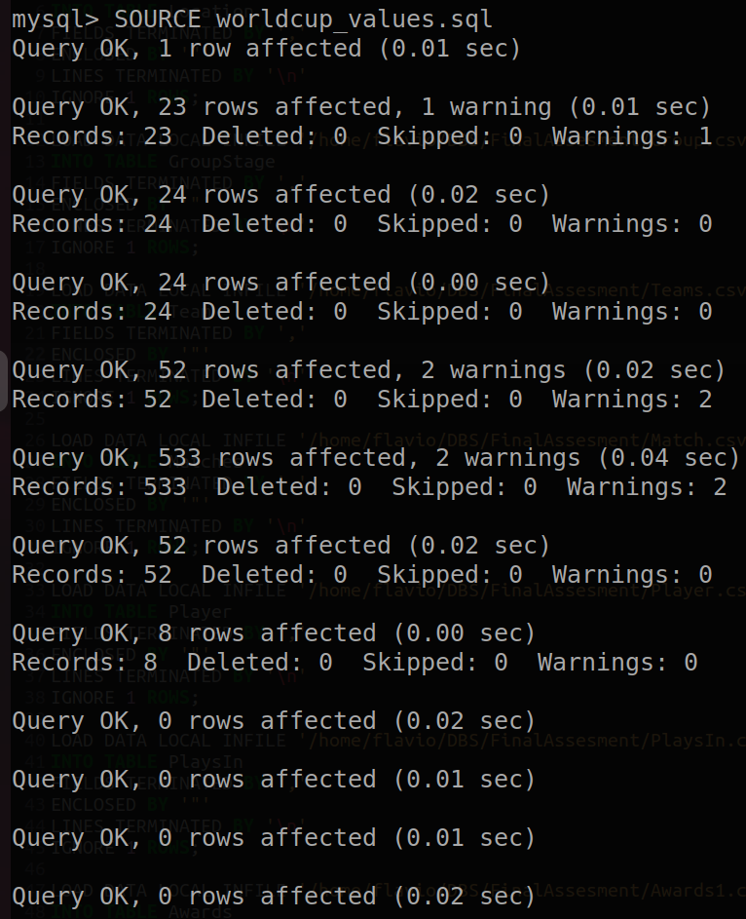

# QUERY EXECUTION

Run the built-in queries to get the desired data from the database. Test the database’s functionality using the following queries.

1. Get players who have scored more than 50 goals in their career

SELECT * FROM Player WHERE goals > 50;

1. This query will return the names of teams that have qualified for the next stage

SELECT group_name, team FROM GroupStage WHERE qualified = 'Q';

1. The query shows a summary of each game

SELECT CONCAT(homeTeam, ' vs ', awayTeam) AS Matchs, CONCAT(homeScore, ' - ', awayScore) AS Scores, winner AS Winner FROM Matches;

1. Calculate the difference in the number of days between the first match of the knockout stage (round of 16) and the final match

SELECT DATEDIFF( (SELECT MAX(m_date) FROM Matches), (SELECT MIN(m_date) FROM Matches WHERE stage = 'Round of 16') ) AS days_between_first_and_final_match;

1. Retrieves the team names, team IDs, and their respective group names for teams that have not advanced to the next stage

SELECT G.group_name, T.team_name FROM Team T LEFT JOIN GroupStage G ON T.team_name = G.team WHERE G.qualified = 'N' ORDER BY G.group_name;

1. Retrieving the data about award winners of the world cup

SELECT DISTINCT P.name, P.country, P.club, P.goals

FROM Player AS P

WHERE P.playerID IN (

SELECT A.playerID

FROM Awards AS A

)

ORDER BY P.goals DESC;

1. Retrieves comprehensive information about the venues where the matches were hosted

SELECT M.venue, L.stadium_name, L.seat_capacity, M.total_attendance FROM (SELECT venue, SUM(attendance) AS total_attendance FROM Matches GROUP BY venue) AS M JOIN Location AS L ON M.venue = L.name ORDER BY M.total_attendance DESC;

1. Retrieving top scoring teams in the 2019 fifa world cup group stage

SELECT GS.year, GS.team,

SUM(IF(GS.team = M.homeTeam, M.homeScore, IF(GS.team = M.awayTeam, M.awayScore, 0))) AS total_goals_scored

FROM GroupStage GS

JOIN Matches M ON GS.year = M.year AND (GS.team = M.homeTeam OR GS.team = M.awayTeam)

WHERE GS.year = 2019

GROUP BY GS.year, GS.team

ORDER BY total_goals_scored DESC;

**Stored Procedures:**

* CALL GetPlayersByTeam('Brazil');
* CALL CalculateWinPercentage('Brazil', 2019);

# database connectivity and python implementation

Before connecting the database with python it is required to run the following commands to ensure the program runs seamlessly.

Check if python3 is intalled already: python3 -V

pip install mysql-connector-python

pip install tabulate

run the python file using the command

python3 FIFAWWorldCup.py

and enter the same username and password which are used to login to the MySQL server and check for the message displayed as Connected Successfully

